***Assignment on Creating Vpcs, Subnets and Routers, and attaching the gate way for this vpcs***

***MENTOR BY :-*  *SUNIL BASAVARAJ***

**1. Prerequisites**

* AWS console

*  IAM

* VPCS

*  SUBNETS

**# ROUTERS**

**# INTERNET GATEWAYS**

**2. Create vpc to create that enter in to the aws console and navigate to vpc**

**a. After navigating the vpc and enter in to the vpc and select create vpc**

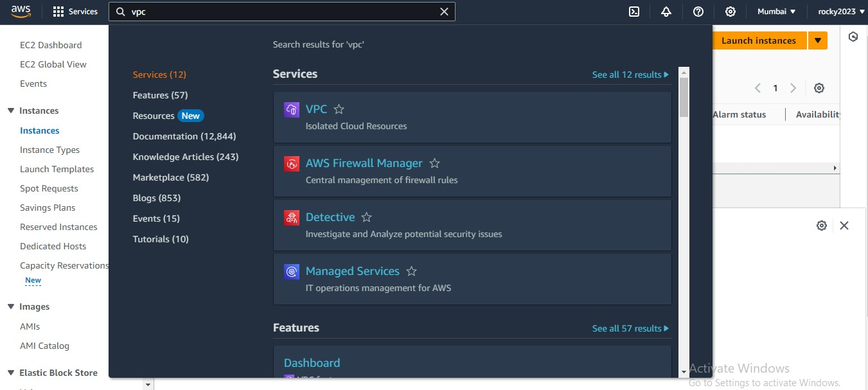

**3. Create vpc and add some requisites show below**

**a. Select vpc only**

**b. In cdr block select (ipv4 CIDR MANULA INPUT)**

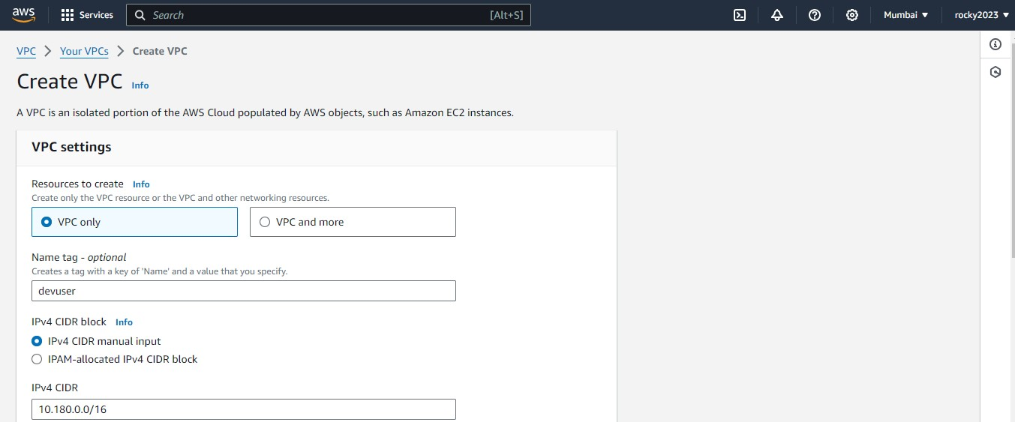

**4. After giving requisites select create vpc .**

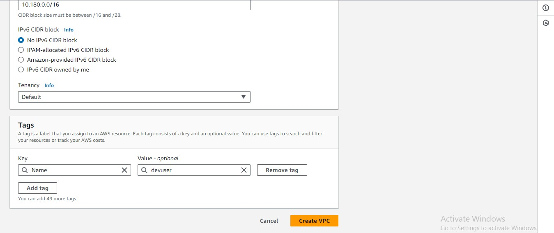

**5. Vpc created successfully and next go for creating igw (internet gate way)**

**To select igw it shows left side vpc list select their .**

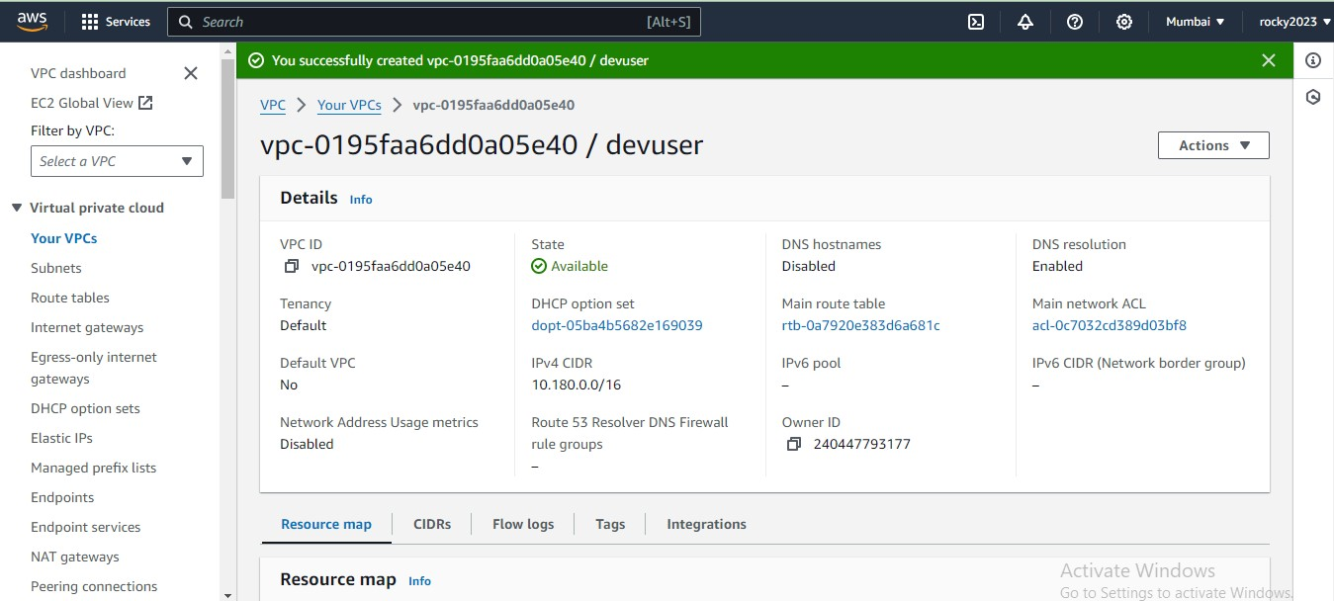

**6. Create internet gateway by selecting IGW .**

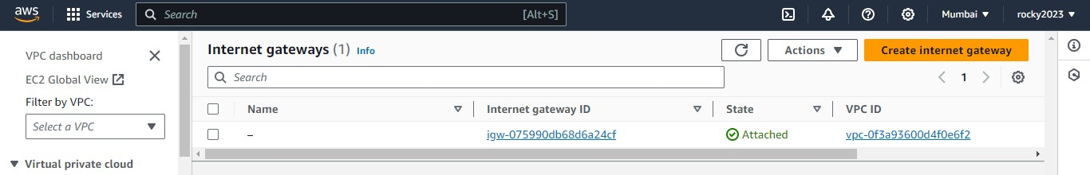

**7. Create Igw by adding some credentials.**

**a. Give tag name.**

**b.Next click on create internet gateway option.**

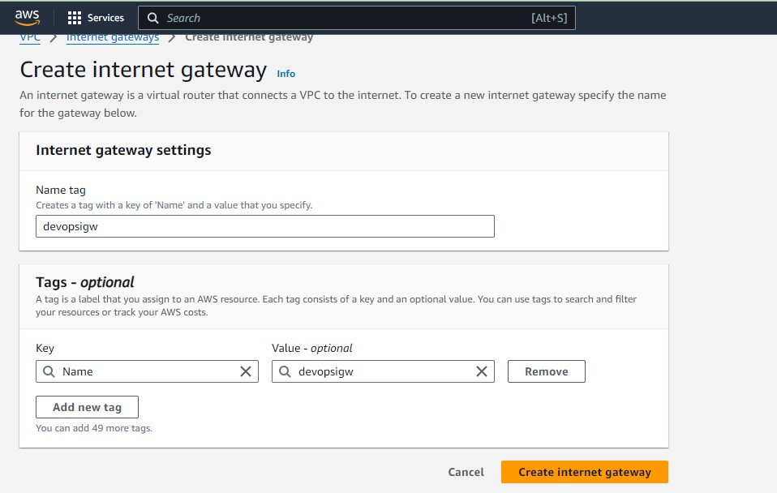

**8. After creating igw next attach to vpc it shows left side top .**

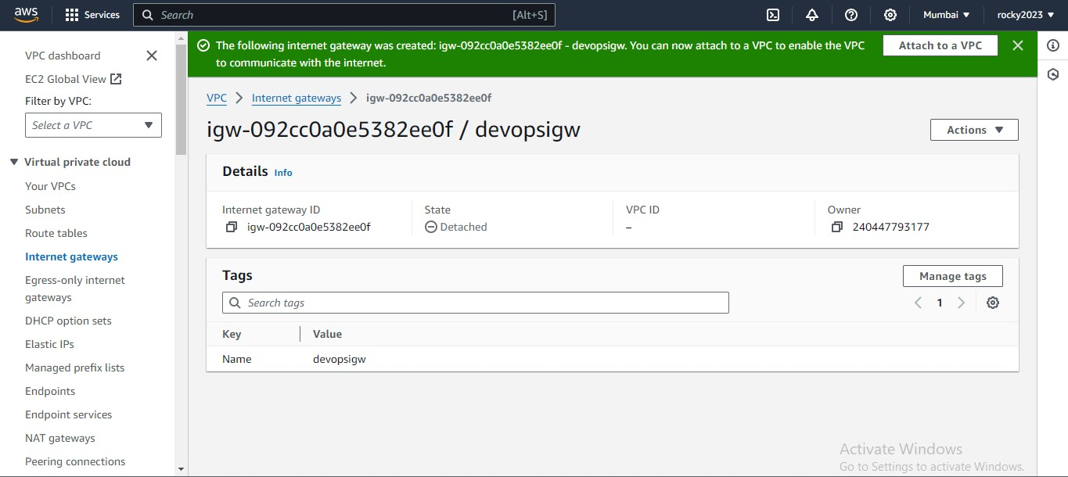

**9. Inside attach to vpc add ur created vpc by clicking on that box**

**a. Next click on attach internet gateway button.**

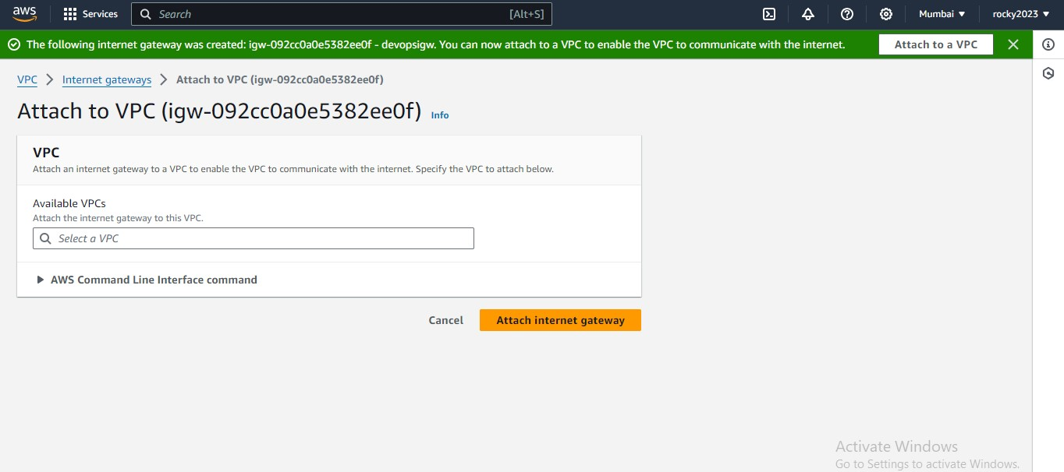

**10. Below imag shows clearly that igw attached to the vpc.**

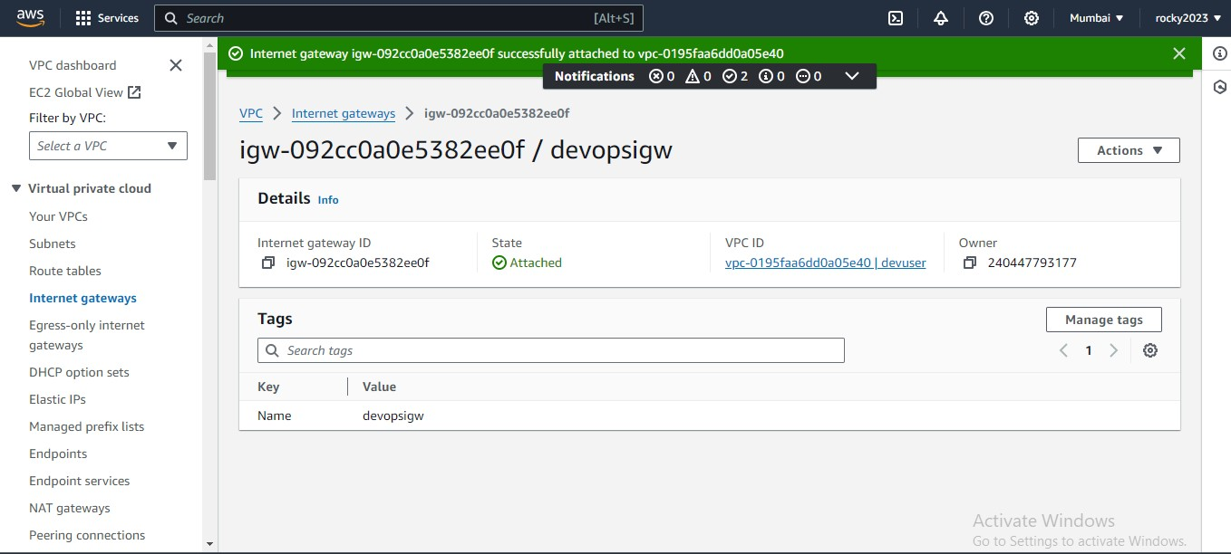

**11. Created subnets will show on left side of the vpc list.**

**a. Subnets for 2 Public and 2 private .**

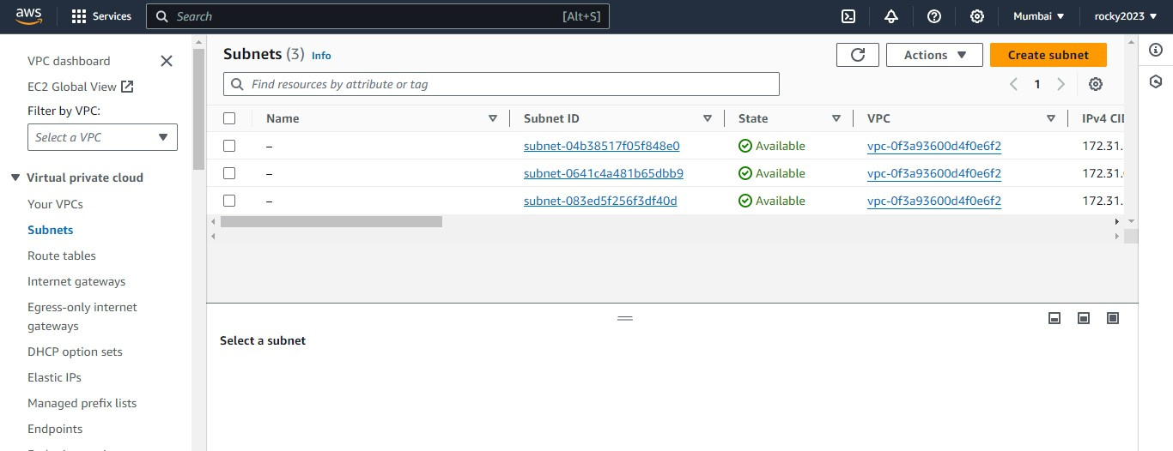

**12. Add credentials in that boxes as shown in below image.**

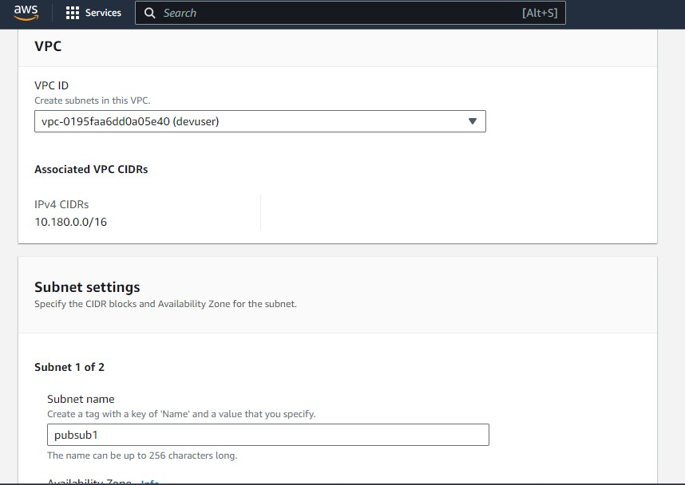

1. **Continued from the above image add credentials to end of the page.**

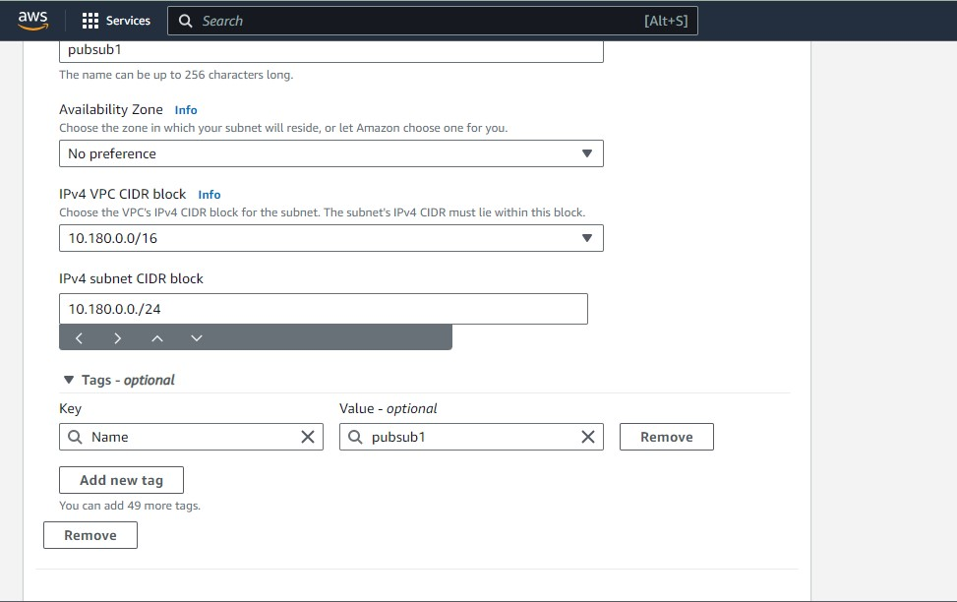

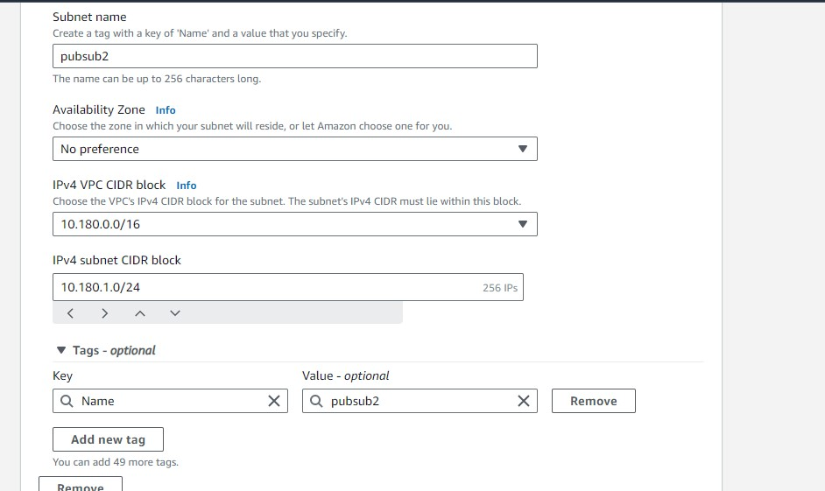

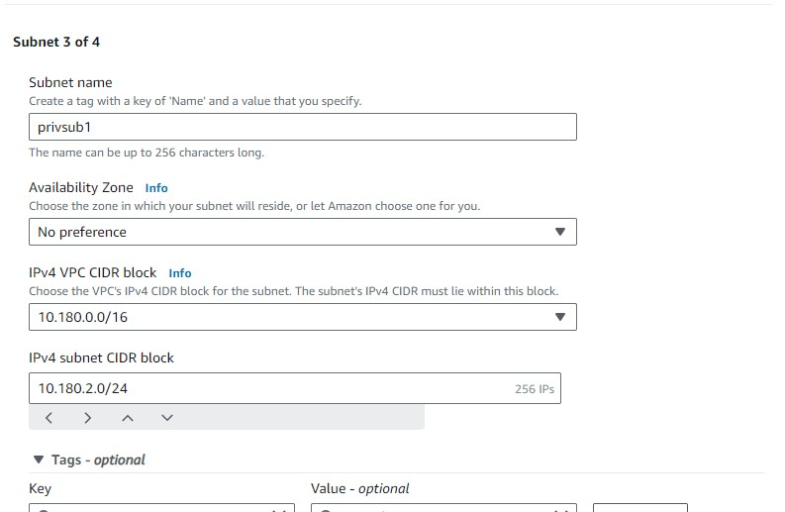

**13. Finally Subnets created**

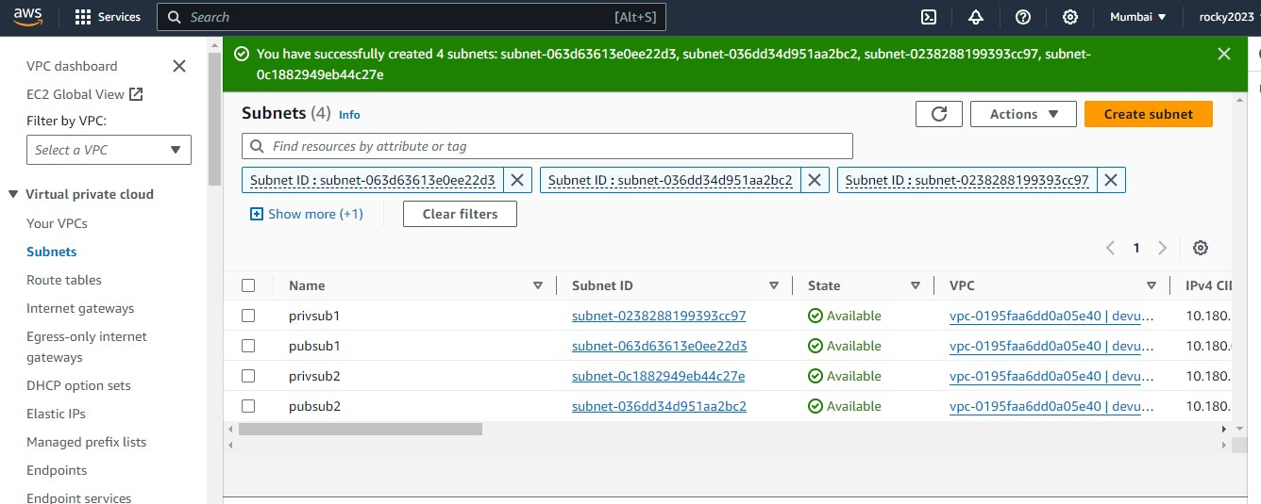



**14. Create route tables for public and private.**

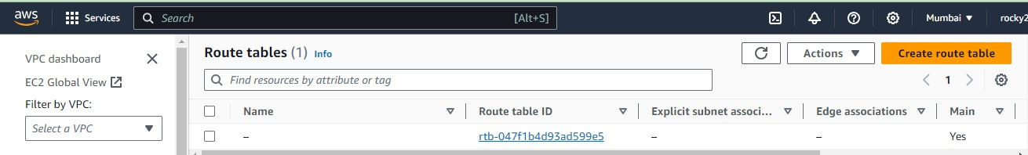

**15. After entering in to the route table add details for that as shown in below image.**

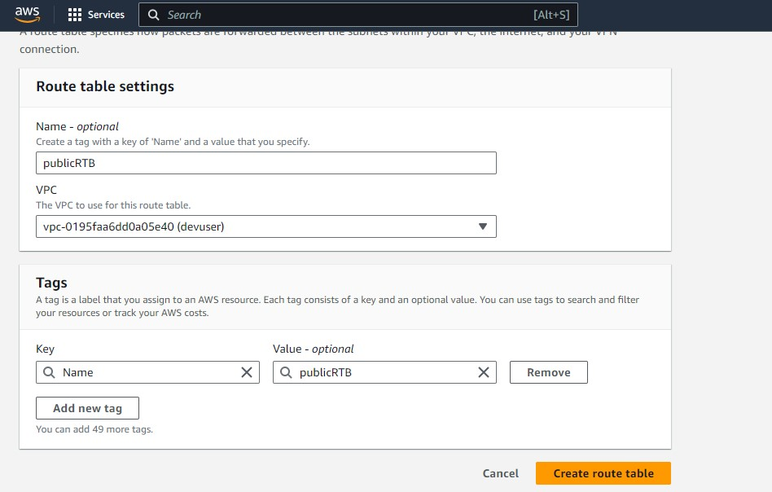

**16. Below image show succesfull creation of route tables.**

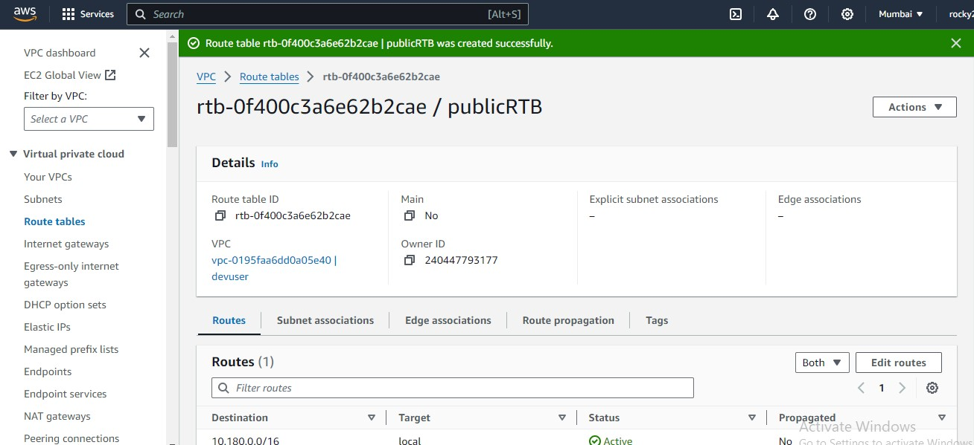

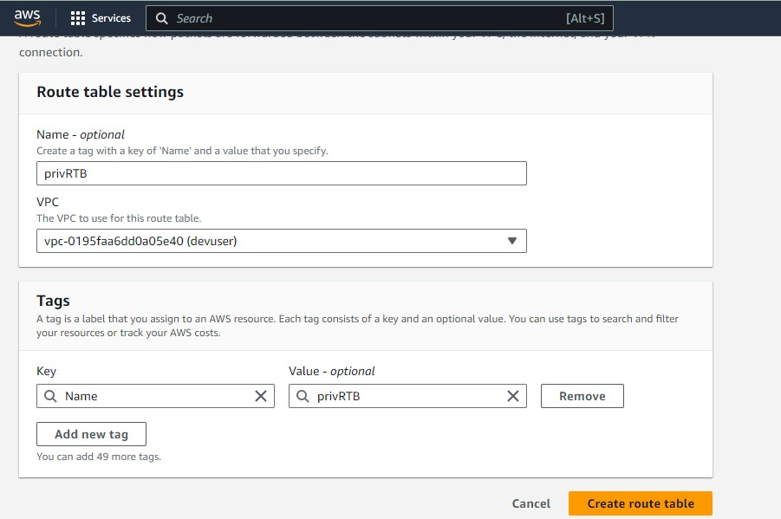

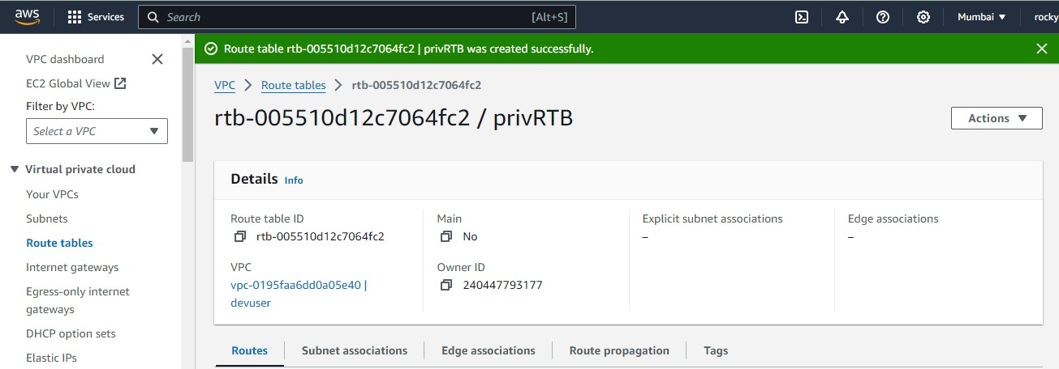

**17. Next part is edit submnet associations.**

**a. Select one by one like public first and second private to edit**

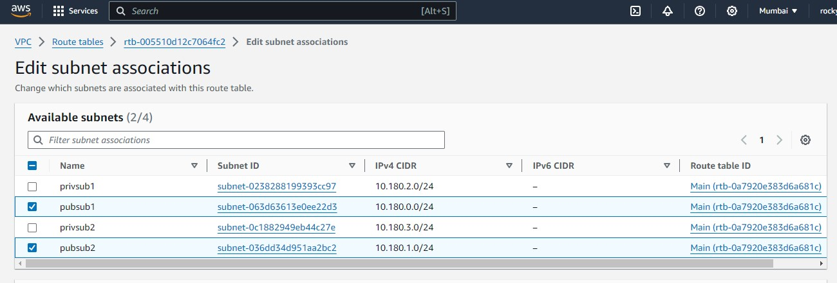

**18. By selecting option edit route it will be done and add required details shon below image.**

